**Week 5**

**Microservices with Spring Boot 3 and Spring Cloud**

**Example 1: Creating Microservices for account and loan**

**Scenario:** In this hands on exercises, we will create two microservices for a bank. One microservice for handing accounts and one for handling loans. Each microservice will be a specific independent Spring RESTful Webservice maven project having it's own pom.xml. The only difference is that, instead of having both account and loan as a single application, it is split into two different applications. These webservices will be a simple service without any backend connectivity.

**Account Microservice**

* Create folder with employee id in D: drive
* Create folder named 'microservices' in the new folder created in previous step. This folder will contain all the sample projects that we will create for learning microservices.
* Open https://start.spring.io/ in browser
* Enter form field values as specified below: Group: com.cognizant Artifact: account
* Select the following modules o Developer Tools > Spring Boot DevTools o Web > Spring Web
* Click generate and download the zip file

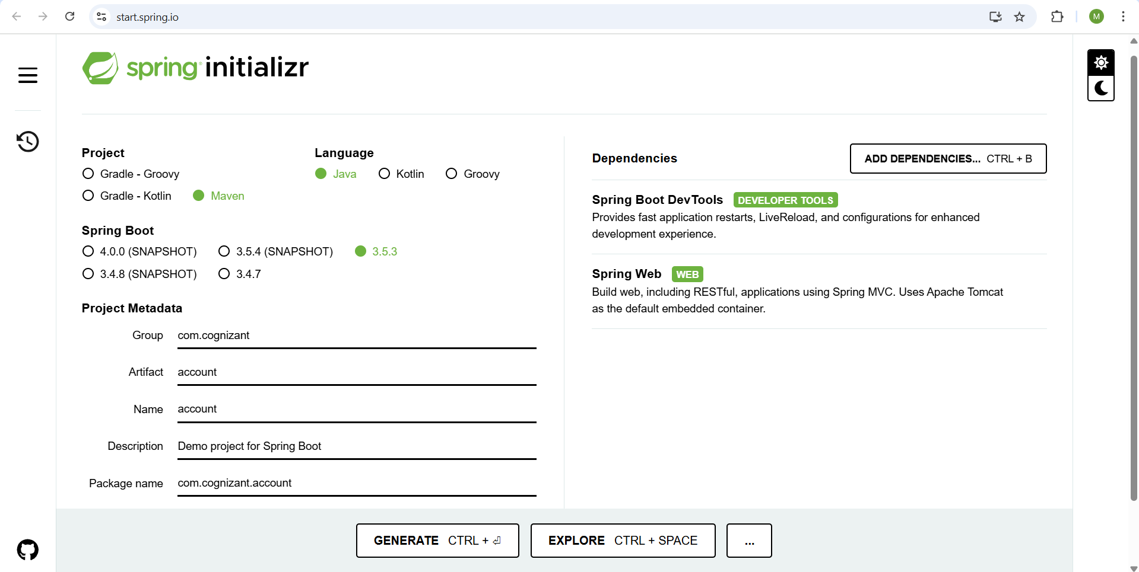

* Extract 'account' folder from the zip and place this folder in the 'microservices' folder created earlier
* Open command prompt in account folder and build using mvn clean package command

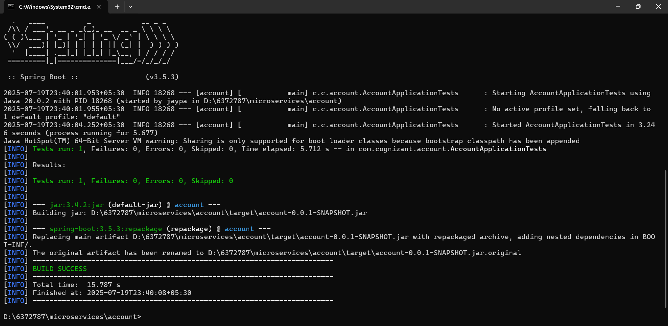

* Import this project in Eclipse and implement a controller method for getting account details based on account number.

Inside thr AccountController.java file ,add the below content:

**package** com.cognizant.account.controller;

**import** org.springframework.web.bind.annotation.*;

@RestController

@RequestMapping("/accounts")

**public** **class** AccountController {

@GetMapping("/{number}")

**public** Account getAccount(@PathVariable String number) {

**return** **new** Account(number, "savings", 12345);

}

}

**class** Account {

**private** String number;

**private** String type;

**private** **double** balance;

**public** Account(String number, String type, **double** balance) {

**this**.number = number;

**this**.type = type;

**this**.balance = balance;

}

**public** String getNumber() {

**return** number;

}

**public** **void** setNumber(String number) {

**this**.number = number;

}

**public** String getType() {

**return** type;

}

**public** **void** setType(String type) {

**this**.type = type;

}

**public** **double** getBalance() {

**return** balance;

}

**public** **void** setBalance(**double** balance) {

**this**.balance = balance;

}

}

* Run the AccountApplication.java class.

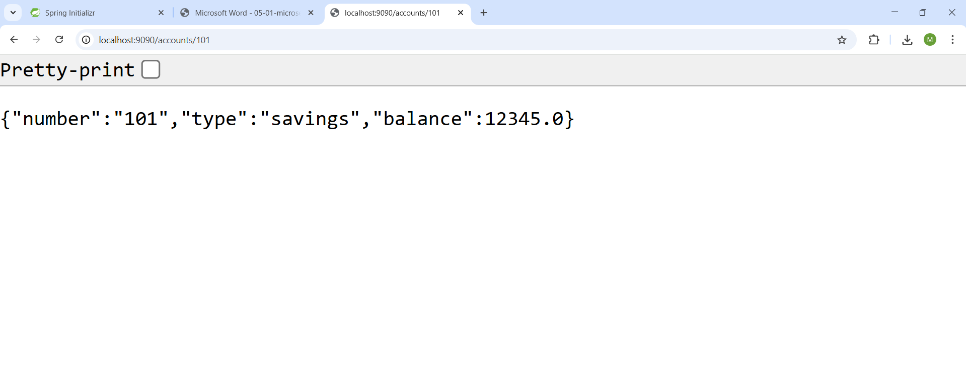

**Loan Microservice**

* Create folder with employee id in D: drive
* Create folder named 'microservices' in the new folder created in previous step. This folder will contain all the sample projects that we will create for learning microservices.
* Open https://start.spring.io/ in browser
* Enter form field values as specified below: Group: com.cognizant Artifact: loan
* Select the following modules o Developer Tools > Spring Boot DevTools o Web > Spring Web
* Click generate and download the zip file

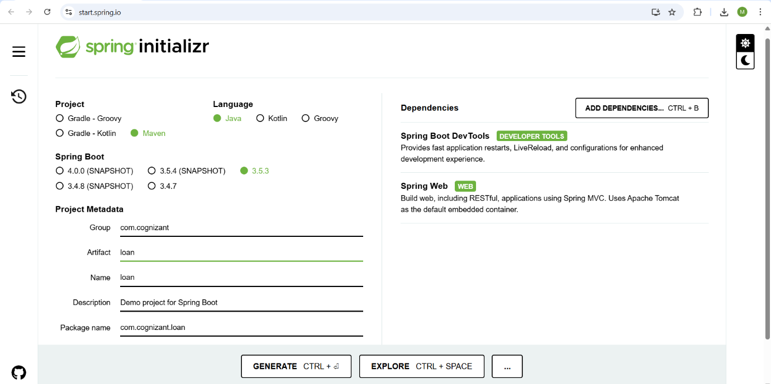

* Extract 'account' folder from the zip and place this folder in the 'microservices' folder created earlier
* Open command prompt in account folder and build using mvn clean package command

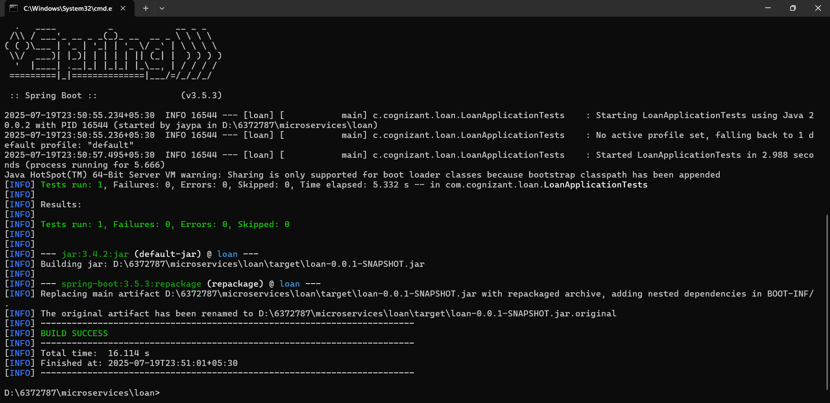

* Import this project in Eclipse and implement a controller method for getting account details based on loan number.

Inside thr LoanController.java file ,add the below content:

**package** com.cognizant.loan.controller;

**import** org.springframework.web.bind.annotation.*;

@RestController

@RequestMapping("/loans")

**public** **class** LoanController {

@GetMapping("/{number}")

**public** Loan getLoan(@PathVariable String number) {

**return** **new** Loan(number, "House", 1000000, 3258, 18);

}

}

**class** Loan {

**private** String number;

**private** String type;

**private** **int** loan;

**private** **int** emi;

**private** **int** tenure;

**public** Loan(String number, String type, **int** loan, **int** emi, **int** tenure) {

**this**.number = number;

**this**.type = type;

**this**.loan = loan;

**this**.emi = emi;

**this**.tenure = tenure;

}

**public** String getNumber() {

**return** number;

}

**public** **void** setNumber(String number) {

**this**.number = number;

}

**public** String getType() {

**return** type;

}

**public** **void** setType(String type) {

**this**.type = type;

}

**public** **int** getLoan() {

**return** loan;

}

**public** **void** setLoan(**int** loan) {

**this**.loan = loan;

}

**public** **int** getEmi() {

**return** emi;

}

**public** **void** setEmi(**int** emi) {

**this**.emi = emi;

}

**public** **int** getTenure() {

**return** tenure;

}

**public** **void** setTenure(**int** tenure) {

**this**.tenure = tenure;

}

}

* Run the AccountApplication.java class.

